

IT INDUSTRY

DARSHAN GOSWAMI



May 22, 2024

darshan goswami

[Company address]

**1. What is software? What is software Engineering ?**

**What is software.**

Software is a collection of instructions, programs, and data that enables computers and other digital devices to perform specific tasks, process information, and interact with users. It encompasses a wide range of applications, from operating systems and utilities that manage computer hardware to specialized programs for tasks such as word processing, web browsing, and video editing.

At its core, software consists of code written in programming languages, which provide a structured way to communicate with computers and specify the steps necessary to accomplish a task. Programming languages range from low-level languages like machine code, which directly correspond to the binary instructions executed by a computer's processor, to high-level languages like Python, Java, and C++, which offer greater abstraction and are easier for humans to understand and work with.

Software can be broadly categorized into two main types: system software and application software. System software includes the fundamental programs and utilities that enable a computer to operate and manage its hardware resources. This includes operating systems like Windows, macOS, and Linux, as well as device drivers and system utilities.

Application software, on the other hand, consists of programs designed to perform specific tasks or functions for end users. This category encompasses a wide range of software applications, including productivity tools like word processors, spreadsheets, and presentation software; communication tools like email clients and messaging apps; entertainment software like video games and media players; and specialized software for industries such as healthcare, finance, and engineering.

The development of software is a complex and iterative process that typically involves multiple stages, including requirements analysis, design, implementation, testing, and deployment. Throughout this process, developers use various tools and methodologies to collaborate, write code, test functionality, and ensure quality and reliability.

In conclusion, software is the backbone of modern technology, enabling computers and other digital devices to perform a wide range of tasks and functions. From operating systems and utilities to productivity tools and entertainment apps, software shapes the way we interact with technology and influences virtually every aspect of modern life.

**What is software engineering?**

Software engineering is a discipline that encompasses the systematic, disciplined, and quantifiable approach to the development, operation, and maintenance of software. It applies engineering principles and practices to design, develop, test, deploy, and maintain software systems efficiently and reliably.

At its core, software engineering focuses on creating high-quality software solutions that meet the needs and requirements of users, businesses, and organizations. This involves a structured and organized approach to software development, encompassing various stages and processes to ensure that the final product is robust, scalable, and maintainable.

Key aspects of software engineering include:

1. **Requirements Engineering**: Understanding and defining the needs and specifications of software systems, including functional and non-functional requirements, to ensure that the final product meets user expectations.
2. **Design:** Creating the architecture and structure of software systems, including defining modules, components, interfaces, and data structures, to ensure that the system is scalable, maintainable, and extensible.
3. **Implementation:** Writing code and building software systems according to the design specifications, using programming languages, frameworks, and libraries to translate requirements into executable software.
4. **Testing:** Verifying and validating software systems to ensure that they meet quality standards, including functional correctness, reliability, performance, security, and usability. This involves various testing techniques, such as unit testing, integration testing, system testing, and acceptance testing.
5. **Deployment:** Installing, configuring, and deploying software systems in production environments, ensuring that they are properly installed, configured, and integrated with existing infrastructure and systems.
6. **Maintenance:** Providing ongoing support, updates, and maintenance for software systems, including bug fixes, security patches, performance enhancements, and feature updates, to ensure that they remain operational and effective over time.

Software engineering also emphasizes principles such as abstraction, modularity, encapsulation, reusability, and maintainability to improve the quality, productivity, and efficiency of software development. It encompasses various methodologies, frameworks, and best practices, such as agile development, waterfall model, DevOps, continuous integration, and test-driven development, to adapt to different project requirements and constraints.

Overall, software engineering plays a crucial role in the creation and evolution of software systems, ensuring that they are developed, deployed, and maintained in a systematic, reliable, and efficient manner to meet the needs of users and stakeholders.

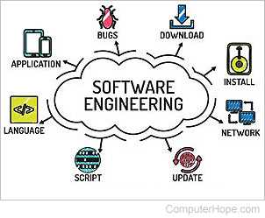

Top of Form

Top of Form

**2. Explain types of software?**

Certainly! Software can be broadly categorized into several types based on their purpose, functionality, and target users. Here are some common types of software:

**1. System Software:**

**- Operating Systems**: These are the core software that manages computer hardware and provides essential services and functions for other software applications. Examples include Windows, macOS, Linux, iOS, and Android.

**- Device Drivers:** These software components facilitate communication between the operating system and hardware devices, enabling them to interact and function properly.

**2. Application Software:**

**- Productivity Software:** These are tools designed to help users perform tasks more efficiently, such as word processors (e.g., Microsoft Word, Google Docs), spreadsheets (e.g., Microsoft Excel, Google Sheets), presentation software (e.g., Microsoft PowerPoint, Google Slides), and email clients (e.g., Microsoft Outlook, Gmail).

**- Communication Software:** These enable users to communicate and collaborate with others, including email clients, instant messaging apps (e.g., WhatsApp, Slack), video conferencing tools (e.g., Zoom, Skype), and social media platforms (e.g., Facebook, Twitter).

**- Entertainment Software:** These include video games, simulations, and other recreational programs designed for entertainment purposes. Video games can further be categorized into genres like action, adventure, role-playing, simulation, strategy, and more.

**- Educational Software:** These are tools and applications designed to facilitate learning and education, including interactive tutorials, educational games, language learning software, and virtual learning environments.

**- Business Software:** These are specialized tools used in various industries and sectors to manage business processes, operations, and data. Examples include customer relationship management (CRM) software, enterprise resource planning (ERP) systems, accounting software, and inventory management systems.

**3. Embedded Software:**

- This type of software is embedded within hardware devices and systems to control their functionality and behavior. Examples include firmware in electronic devices like routers, smart appliances, automotive systems, and industrial machinery.

**4. Middleware:**

- Middleware refers to software that acts as a bridge between different software applications or components, enabling communication, data management, and integration across heterogeneous systems. Examples include web servers, application servers, message-oriented middleware, and database middleware.

**5. Open Source Software:**

- Open source software refers to software whose source code is freely available for users to view, modify, and distribute under an open source license. Examples include the Linux operating system, the Apache web server, the Firefox web browser, and the WordPress content management system.

These are just some of the broad categories of software, and there are countless specific applications and tools within each category tailored to different needs and requirements.

**3.What is SDLC ? Explain each phase of SDLC**

**What is SDLC?**

SDLC stands for Software Development Life Cycle. It refers to the process used by software developers to design, develop, test, deploy, and maintain software applications. SDLC provides a structured framework for managing the entire software development process, from initial concept to final release and beyond.

The stages of the SDLC typically include:

**1. Planning:** This stage involves defining the scope, objectives, requirements, and constraints of the project. It may include conducting feasibility studies, defining project timelines, and allocating resources.

**2. Analysis:** In this stage, developers gather and analyze requirements from stakeholders to understand the functionality and features needed in the software.

**3. Design:** Based on the requirements gathered in the analysis phase, developers create a detailed design for the software, including architecture, data structures, algorithms, and user interface.

**4. Implementation**: This stage involves writing code according to the design specifications. Developers may use programming languages, frameworks, and libraries to translate requirements into executable software.

**5. Testing:** After implementation, the software undergoes rigorous testing to ensure that it meets quality standards and performs as expected. This includes various testing techniques such as unit testing, integration testing, system testing, and user acceptance testing.

**6. Deployment:** Once the software has been thoroughly tested and validated, it is deployed in production environments. This may involve installation, configuration, and integration with existing systems and infrastructure.

**7. Maintenance:** After deployment, the software requires ongoing maintenance and support to address issues, fix bugs, and make updates. This may include releasing patches, updates, and new versions of the software as needed.

Throughout the SDLC, developers follow best practices, methodologies, and tools to manage the development process efficiently and effectively. Common SDLC methodologies include Waterfall, Agile, Scrum, and DevOps, each with its own approach to managing project timelines, requirements, and deliverables. The choice of methodology depends on factors such as project size, complexity, and team structure.

**Explain each phase of SDLC**

**1. Planning Phase:**

**- Objective:** Define the scope, objectives, and constraints of the project.

**- Activities:** Conduct feasibility studies, identify stakeholders, establish project timelines, allocate resources, and create a project plan.

**- Deliverables:** Project plan, scope statement, feasibility report.

**2. Analysis Phase:**

**- Objective:** Gather and analyze requirements from stakeholders to understand the functionality and features needed in the software.

**- Activities:** Elicit requirements through interviews, surveys, and workshops; document requirements using techniques like use cases, user stories, and requirement specifications.

**- Deliverables:** Requirement specifications, use cases, user stories, requirement traceability matrix.

**3. Design Phase:**

**- Objective:** Create a detailed design for the software, including architecture, data structures, algorithms, and user interface.

**- Activities:** Architectural design, database design, user interface design, component design, and detailed design documentation.

**- Deliverables:** System architecture diagram, database schema, user interface prototypes, design documents.

**4. Implementation Phase:**

**- Objective:** Write code according to the design specifications and build the software.

**- Activities:** Coding, unit testing, code reviews, and integration of components.

**- Deliverables:** Source code, executable software, unit test cases, code documentation.

**5. Testing Phase:**

**- Objective:** Verify and validate the software to ensure that it meets quality standards and performs as expected.

**- Activities:** Various testing techniques such as unit testing, integration testing, system testing, regression testing, and user acceptance testing.

**- Deliverables:** Test plans, test cases, test reports, defect reports.

**6. Deployment Phase:**

**- Objective:** Deploy the software in production environments.

**- Activities:** Installation, configuration, integration with existing systems, and user training.

**- Deliverables:** Deployed software, installation guides, user manuals.

**7. Maintenance Phase:**

**- Objective:** Provide ongoing support, updates, and maintenance for the software.

**- Activities:** Bug fixes, security patches, performance enhancements, feature updates, and user support.

**- Deliverables:** Patch releases, software updates, maintenance documentation..

**4).What is Flow chart? Create a flowchart to make addition of two numbers**

**Flowchart: A flowchart is a type of diagram that represents a workflow or process.A flowchart can also be defined as a diagrammatic representation of an algorithm**

Algorithm: A set of fintite rules or instruction to b followed in claclutions or other problem – solving operations.

#include<stdio.h>

Int main()

{

Int n1,n2,ans;

Printf(“enter 2 valued”);

Scanf(%d %d”,&n1,&n2);

Ans=n1+n2;

Printf(“%d” , ans);

Return 0;  
}

**Algorithm:**

1. Start

2)Declare variables n1,n2,ans;

3)display enter 2 values

4) read values of n1,n2 from user

5)display ans

6)stop

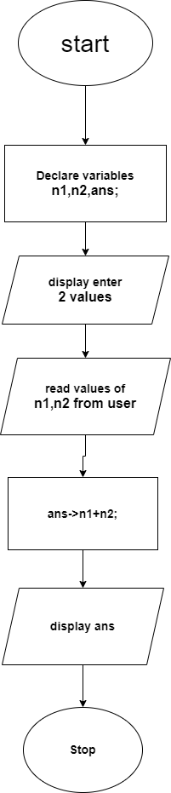

**What is Use case Diagram? Create a use-case on bill payment on paytm.**

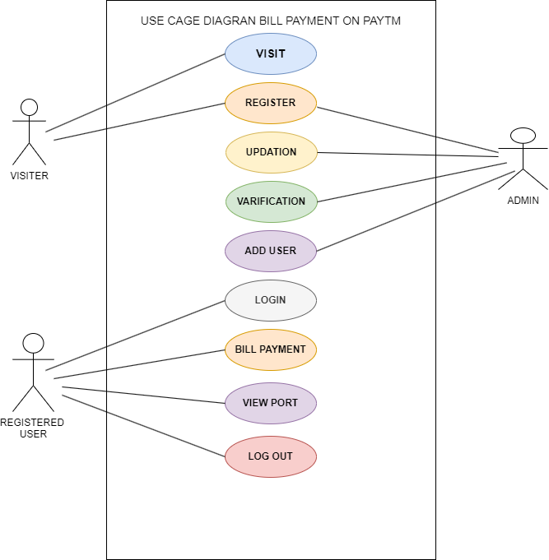

**What is DFD? Create a DFD diagram on Flipkart**

Use-case diagrams describe the high-level functions and scope of a system. These diagrams also identify the interactions between the system and its actors. The use cases and actors in use-case diagrams describe what the system does and how the actors use it, but not how the system operates internally.

**0 LEVEL**

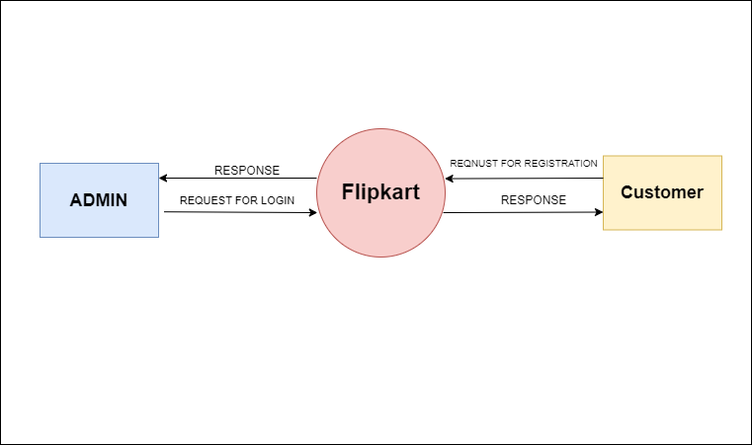

**1 LEVEL**

DFD stands for Data Flow Diagram, which is a graphical representation of the flow of data through a system. It shows how data enters and leaves the system, as well as how it is processed within the system.

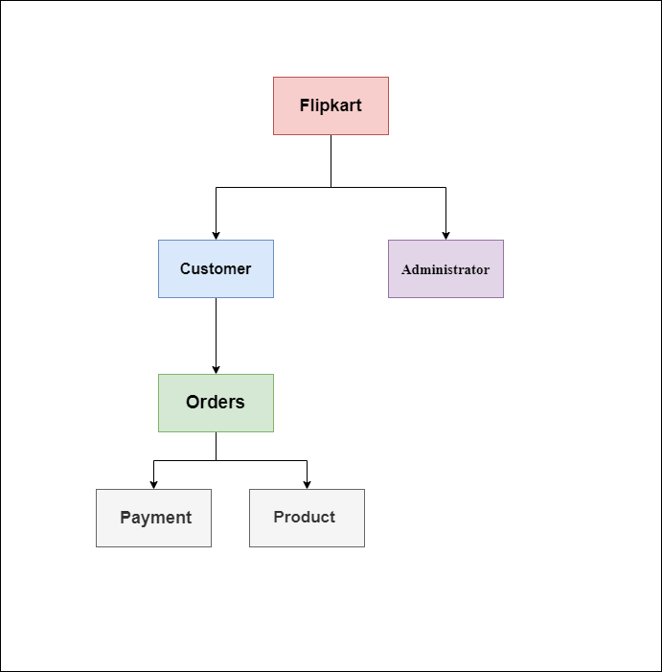

• **Flipkart**: The main entity or system.

• **Customer**: Represents users who interact with the system by browsing products, placing orders, etc.

• **Orders**: Data flow representing the process of customers placing orders.

• **Payment**: Represents the process of payment for orders.

• **Product**: Represents the products offered for sale on Flipkart.

**Level 2**

DFD stands for Data Flow Diagram, which is a graphical representation of the flow of data through a system. It shows how data enters and leaves the system, as well as how it is processed within the system.

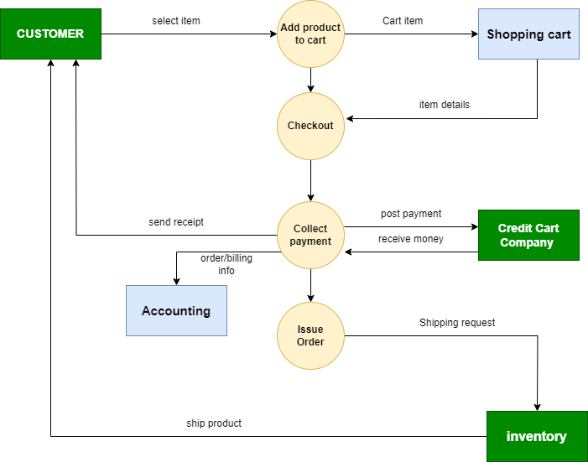

**THANK YOU**